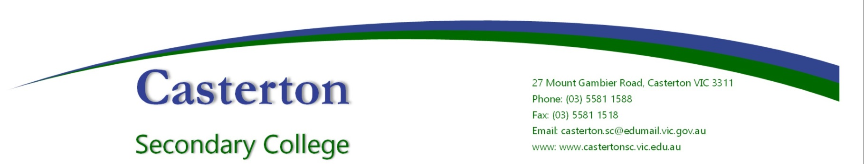
FOUR CRITICAL ACTIONS FOR SCHOOLS
Responding to Incidents, Disclosures and Suspicions of Child Abuse
YOU MUST TAKE ACTION
As a school staff member, you play a critical role in protecting children in your care.
- You must act, by following the 4 critical actions, as soon as you witness an incident, receive a disclosure or form a reasonable belief that a child has, or is at risk of being abused.
- You must act if you form a suspicion/reasonable belief, even if you are unsure and have not directly observed child abuse (e.g. if the victim or another person tells you about the abuse).
- You must use the Responding to Suspected Child Abuse template to keep clear and comprehensive notes.
* A reasonable belief is a deliberately low threshold. This enables authorities to investigate and take action

ACTION 1: Responding to an emergency
If there is no risk of immediate harm go to ACTION 2.
If a child is at immediate risk of harm you must ensure their safety by:
- separating alleged victims and others involved
- administering first aid
- calling 000 for urgent medical and/or police assistance to respond to immediate health or safety concerns
- identifying a contact person at the school for future liaison with Police.
Where necessary you may also need to maintain the integrity of the potential crime scene and preserve evidence.
Action 2: reporting to authorities
As soon as immediate health and safety concerns are addressed you must report all incidents, suspicions and disclosures of child abuse as soon as possible. Failure to report physical and sexual child abuse may amount to a criminal offence.
If the source of suspected abuse is from within the school:
Victoria Police
You must report all instances of suspected child abuse involving a school staff member, contractor or volunteer to Victoria Police.
You must also report internally to:
Government schools
- School Principal and/or leadership team
- Employee Conduct Branch
- DET Security Services Unit

If the source of suspected abuse is from within the family or community
DHHS CHILD PROTECTION
You must report to DHHS Child Protection if a child is considered to be:
- in need of protection from child abuse
- at risk of being harmed (or has been harmed) and the harm has had, or is likely to have, a serious impact on the child’s safety, stability or development.
VICTORIA POLICE
You must also report all instances of suspected sexual abuse (including grooming) to Victoria Police.

You must also report internally to:
GOVERNMENT SCHOOLS
- School Principal and/or leadership team
- DET Security Services Unit

ACTION 3: CONTACTING PARENTS/CARERS
Your Principal must consult with DHHS Child Protection or Victoria Police to determine what information can be shared with parents/carers. They may advise:
- not to contact the parents/carers (e.g. in circumstances where the parents are alleged to have engaged in the abuse, or the child is a mature minor and does not wish for their parents/carers to be contacted)
- to contact the parents/carers and provide agreed information (this must be done as soon as possible, preferably on the same day of the incident, disclosure or suspicion).
ACTION 4: PROVIDING ONGOING SUPPORT
Your school must provide support for children impacted by abuse. This should include the development of a Student Support Plan in consultation with wellbeing professionals. This is an essential part of your duty of care requirements.
Strategies may include development of a safety plan, direct support and referral to wellbeing professionals etc.

You must follow the Four Critical Actions every time you become aware of a further instance or risk of abuse. This includes reporting new information to authorities

If you believe that a child is not subject to abuse, but you still hold significant concerns for their wellbeing you must still act.
This may include making a referral or seeking advice from Child FIRST (in circumstances where the family are open to receiving support), or to DHHS Child Protection or Victoria Police.

CONTACT
DHHS CHILD PROTECTION
AREA
North Division 1300 664 9777
South Division 1300 655 795
East Division 1300 360 391
West Division (Rural) 1800 075 599
West Division (Metro) 1300 664 9777
AFTER HOURS
After hours, weekends, public holidays 13 12 78

CHILD FIRST
www.dhs.vic.gov.au

VICTORIA POLICE
000 or contact your local police station

DET SECURITY SERVICES UNIT
(03) 9589 6266

STUDENT INCIDENT AND RECOVERY UNIT
(03) 9637 2934

EMPLOYEE CONDUCT BRANCH
(03) 9637 2595

POLICY Review and approval
Policy last reviewed | Term 2, 2022
Consultation | Endorsed by School Council 12/09/2022
Approved by | Principal
Next scheduled review date | 2024

