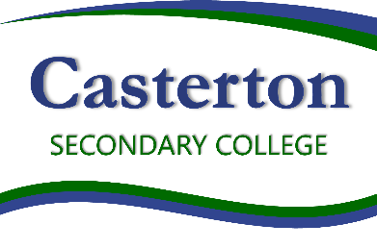

Curriculum initiatives
- The whole school approach to respectful Relationships Respectful is taught in our Health curriculum.
- Year 7 students participate in the e-Smart Digital Licence program
- Year 8 & 9 students participate in the Healthy Minds program
- Year 8 & 11 students participate in the Teen Mental Health program
- Year 8 students participate in the Live 4 Life program
- Senior students participate in the teamwork and leadership program at Noorla Yo-Long.

Students are able to be members of:
- Student Council
- School Council

POLICY Review and approval
Policy last reviewed | Term 2, 2022
Consultation | Endorsed by School Council 12/09/2022
Approved by | Principal
Next scheduled review date | 2024

